Your patient feedback

Frequency and distribution of ratings for the Friends and Family Test question (table 1, graph 1) P1 Cumulative and previous survey information (table 2) P2
Patient comments P2
Patient demographics D1

Supporting documents

Additional information on the Friends and Family Test Sample patient questionnaire

Frequency and distribution of ratings for the Friends and Family Test question

How likely are you to recommend our GP practice to friends and family if they needed similar care or treatment?

Table 1

Criteria category for scoring | Response scale | Number of responses | Percentage of responses*
Promoters | Extremely likely | 24 | 51%
Passive | Likely | 16 | 34%
Detractors | Neither likely nor unlikely | 3 | 6%
 | Unlikely | 1 | 2%
 | Extremely unlikely | 1 | 2%
 | Don't know | 2 | 4%
Total responses to this question |  | 47 | 99%
* May not add up to 100% due to rounding

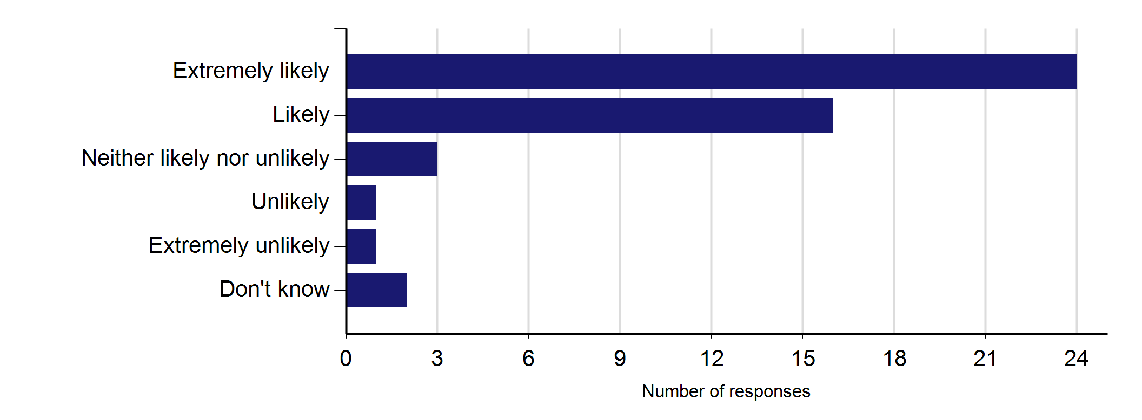
Graph 1

85% of patients who responded to the survey would be either extremely likely or likely to recommend your practice to friends and family if they needed similar care or treatment.
The sum of the 'Extremely likely' and 'Likely' percentage of responses in Table 1 may not equal the percentage in the grey box above due to rounding.

Of those 47 patients who answered the Friends and Family Test question, 46 (98%), filled out a paper questionnaire and 1 (2%), completed a questionnaire online.

Cumulative and previous survey information Table 2
Frequency and distribution of ratings
Extremely likely | Likely | Neither likely nor unlikely | Unlikely | Extremely unlikely | Don't know

 | Total responses to Q1 | Percentage of patients extremely likely or likely to recommend
Cumulative feedback* | 560 | 92%

367 | 146 | 17 | 7 | 10 | 13

*This cumulative feedback is based on the sum of the previous months survey data, as below (up to a maximum of 12 months).
Aug-16 | 47 | 85%
Jul-16 | 50 | 96%
Jun-16 | 46 | 96%
May-16 | 48 | 92%
Apr-16 | 45 | 98%
Mar-16 | 48 | 92%
Feb-16 | 48 | 90%
Jan-16 | 48 | 90%
Dec-15 | 46 | 93%
Nov-15 | 48 | 92%
Oct-15 | 46 | 89%
Sep-15 | 40 | 88%

24 | 16 | 3 | 1 | 1 | 2
34 | 14 | 1 | 0 | 1 | 0
29 | 15 | 1 | 1 | 0 | 0
28 | 16 | 0 | 2 | 2 | 0
36 | 8 | 0 | 1 | 0 | 0
36 | 8 | 2 | 1 | 1 | 0
31 | 12 | 3 | 0 | 0 | 2
31 | 12 | 2 | 0 | 1 | 2
33 | 10 | 0 | 0 | 0 | 3
32 | 12 | 0 | 1 | 1 | 2
32 | 9 | 1 | 0 | 2 | 2
21 | 14 | 4 | 0 | 1 | 0

Patient comments The following comments are from patients who indicated that they were happy for these to be made public.
All comments are included in their entirety but all attempts have been made to remove details which could identify specific patients or practitioners.

Please tell us why you answered as you did in question 1:
- Very nice doctor, he always listens to me.
- Because I do not have to call and book for appointment before seeing my GP.
- The open surgery tries their best to serve everyone at a reasonable time. My questions are always answered to the best of the doctors ability/knowledge.
- One of the doctors is very nice.
- Because they tell us what to do and they give us advice.
- I have been with them for a very long time, the staff are good.
- My family and I have received excellent service.
- I like the service.
- 1. Patients can visit doctors without appointment. 2. Staff are friendly.
- One GP in particular is very attentive to patients' needs and displays empathy. It is very important that a GP cares and listens to patients and this doctor does at all times.
- My GP give me enough time and take every action whenever required.
- The GP has been very kind and supportive towards me and my recent health problems.
- No appointments are necessary.

Please tell us why you answered as you did in question 1:
- Very good service.
- My doctor love him.
- Been a patient here for many years.
- Flexible hours. Fair amount of doctors to see and lady doctor also.
- I don't need appointment. Don't need to wait.
- If I needed any extra treatment I always recommended to go for it.
- Like drop-in service/no appointments don't like appointments rushed and advice not always great.
- Because I like the service here.
- Excellent and efficient service to patients. Smiling and ready to help staff.
- I wouldn't recommend any doctors as something you need.
- The doctors are extremely patient and understanding. The reception staff and nurses always try their hardest to let you see a doctor even when you are not well.
- I have been here for many years and I love it.
- Am happy with their health care services.

Demographics

Q3: Gender

 | Number of responses | Percentage of responses*
Male | 17 | 36%
Female | 28 | 60%
Blank | 2 | 4%
* May not add up to 100% due to rounding

Q4: Age

 | Number of responses | Percentage of responses*
0 - 15 | 0 | 0%
16 - 24 | 1 | 2%
25 - 34 | 13 | 28%
35 - 44 | 11 | 23%
45 - 54 | 11 | 23%
55 - 64 | 7 | 15%
65 - 74 | 2 | 4%
75 - 84 | 2 | 4%
85+ | 0 | 0%
Blank | 0 | 0%
* May not add up to 100% due to rounding

Q5: Ethnic group

 | Number of responses | Percentage of responses*
White | 7 | 15%
Mixed/Multiple ethnic groups | 0 | 0%
Asian/Asian British | 17 | 36%
Black/African/Caribbean/ Black British | 20 | 43%
Other ethnic group | 1 | 2%
Blank | 2 | 4%
* May not add up to 100% due to rounding

Q6: Day-to-day activities limited because of health?

 | Number of responses | Percentage of responses*
Yes, limited a lot | 6 | 13%
Yes, limited a little | 7 | 15%
No | 27 | 57%
Prefer not say | 6 | 13%
Blank | 1 | 2%
* May not add up to 100% due to rounding

Supporting documents

Additional information on the Friends and Family Test

The Friends and Family Test (FFT) is a feedback tool that supports the fundamental principle that people who use NHS services should have the opportunity to provide feedback on their experience that can be used to improve services. It is not a traditional survey. It is a continuous feedback loop between patients and practices.

Practices can use the feedback gathered through the FFT to celebrate successes and to support staff to make improvements where the experience of service does not live up to expectations. FFT results are also one useful source of information which can help to inform choice for patients and the public.

More information and guidance about the use of the FFT in the NHS can be found at http://offlinehbpl.hbpl.co.uk/NewsAttachments/PGH/FFT.pdf and http://www.england.nhs.uk/wp- content/uploads/2014/07/fft-imp-guid-14.pdf.

